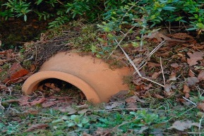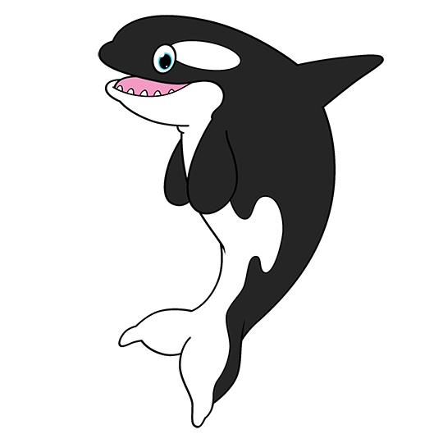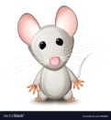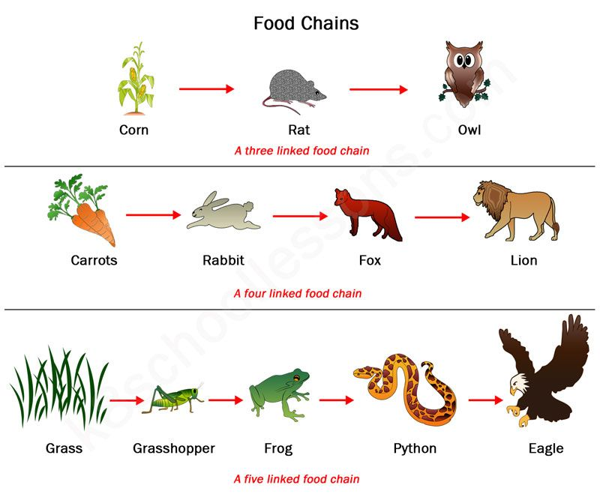

**Geography**

• Use a map of the world and label the continents and oceans.

• Research and draw animals that are found in all corners of the world.

*Are there similarities and differences between the animals?*

*How are the animals adapted to their habitats?*

**Art**

• Take a look at Henri Rousseau ‘The jungle’.

*What do you like about his painting?*

• Create a habitat painting of your own.

All Creatures Great and Small

**Science**

• Use the internet to watch videos of life cycles of animals like butterflies, chickens, tortoises then use your body shapes to represent each stage.

• Create a poster to represent the food chain of animals on land and in water. Label the predator and the prey.

• Find out what Carnivores, Herbivores and Omnivores eat and draw a

dinner plate for each.

**D and T**

• Create a habitat in your garden to welcome the

local wildlife.

* Make an animal puppet

**English**

• Use books in your home or the interest to research an animal of your choice.

• Use your findings to create a non-chronological report about this animal. Tell me about its habitat, diet and physical features.

• Use your super imaginations to write an adventure story about your favourite animal.

• Use your puppet (see Art and DT) to put an a show of your story for your family.

**Maths**

• Take a look around your garden or on your daily walk record and tally the animals you see.

• Use your tally to help you create a pictogram and/or bar graph of your findings.

*Which animal did you find the most of?*

*Which animal did you find the least of?*